**Data Science HealthCare Project Drug**

**Persistance ABC Pharma**



**By : Sourour Cherif**

**Mail : Sourour.cherif@esprit .tn**

**Data Science Engineering Student Esprit Tunisia**

# Problem description



# Business understanding



# Data understanding

To fit any predictive model on a dataset, we need to understand the complexity of the dataset before deciding which predictive model to use to get optimal performance .

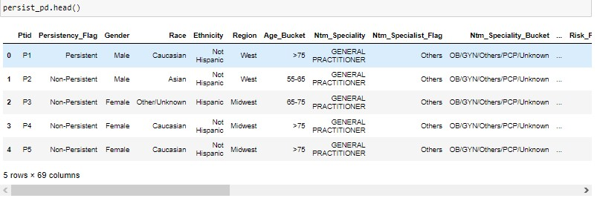

# Type of data

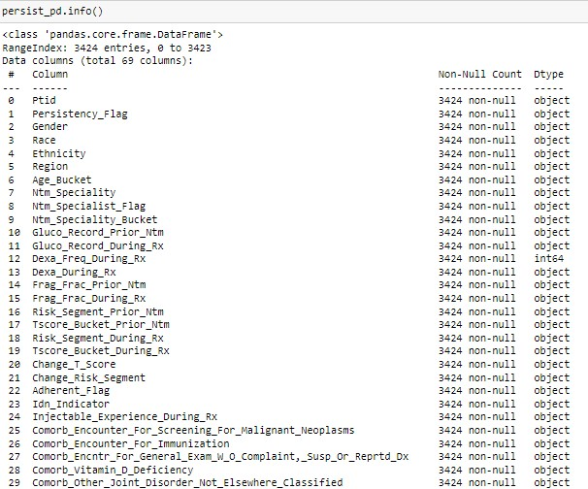

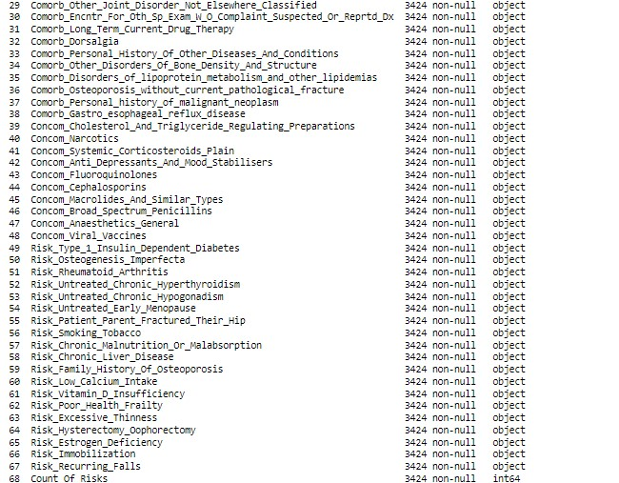

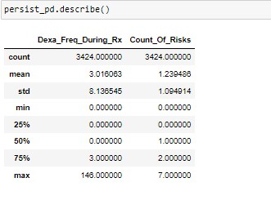

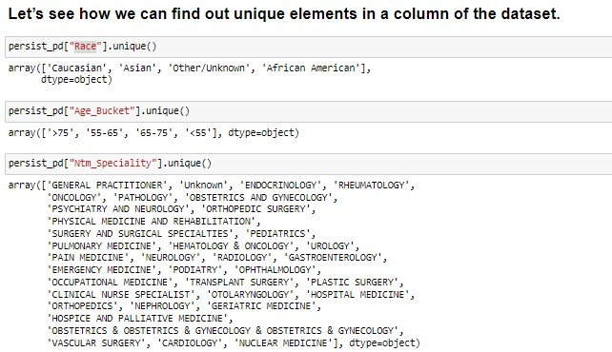

# Data Problems

Data problems such as irrelevant columns , Null values , duplicates , skewed data ,outliers and many others may cause bad predictions …

So we need to check if we have one of them to know then how to overcome it .

* **Skewed Data :**

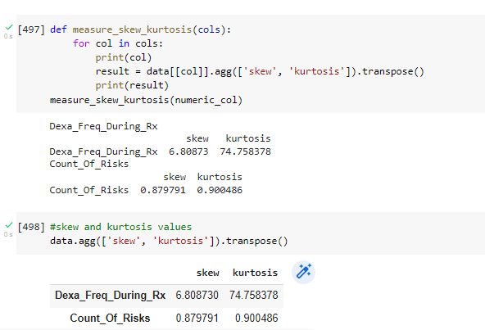

* **Outliers**

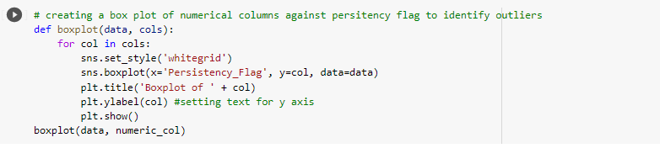

**Solutions :**

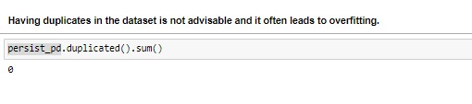

* **There is no duplicates**

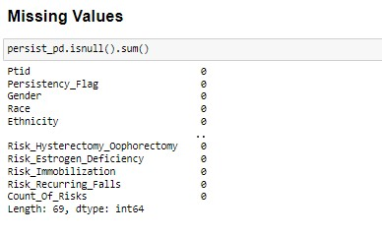

* **No missing Values**

**Eliminating Skewed data**

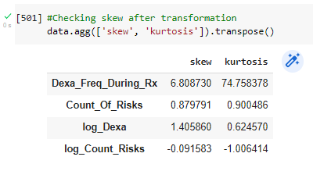

**Example of removing 99% Percentile**

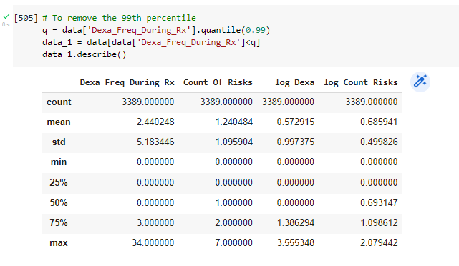

Trying to :

* Remove no significant columns
* Handling with Skewed data
* Detect Outliers using different vizualisation tools